Steps Toward Sustainability:
Cultivating Cross-Campus Buy-in at the College of Charleston
The following is an overview of some of the initiatives we have created to cultivate cross-campus support for inclusive education. One primary goal of our TPSID grant is to foster a sense “shared ownership” in the education of students with intellectual disabilities. Just as students without intellectual disabilities are served by all departments and offices across campus, so too should students with intellectual disabilities be served and supported as an integral part of the mission of the college.
To this end, we have implemented a number of initiatives designed to spark conversation, provide support and training, and promote inclusive practices across campus. We share these initiatives with you in the hopes that they might ignite ideas for cultivating inclusion on your own campus.
Initiative 1: Speaker Series
Each semester we bring a speaker to campus to discuss some aspect of inclusion or disability. Our speakers thus far have included Norman Kunc, Dr. Rosemarie Garland-Thomson, Dr. Michael Berube, and most recently, Dr. Temple Grandin. When a speaker comes to campus, we arrange not only for a public lecture, but also for small group meetings with students, mentors, faculty members, administrators, community leaders, employers, and members of our board of trustees.
As one example, Temple Grandin visited in November and gave a public presentation entitled, The World Needs All Kinds of Minds, to over 1000 people in our community. Attendants included K-12 teachers, parents, self-adovcates, employers, paraprofessionals, and key decision makers within the university. After the talk Temple offered a book signing for 50 lucky attendants chosen at random from the audience. During her visit, she also met in small groups with pre-vet students, students in the REACH program and other students across campus, faculty, and mentors. We held a special reception for Temple with members of our board of trustees, employers, and our top administrators. Finally, we arranged for newspaper and television coverage of her visit. Below are some highlights:
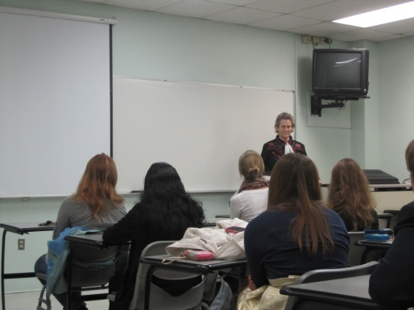
Sessions with students
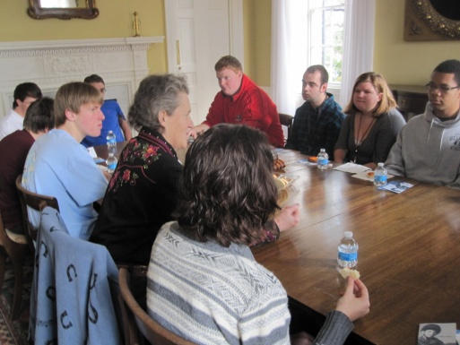

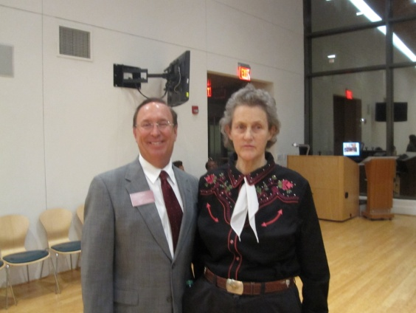
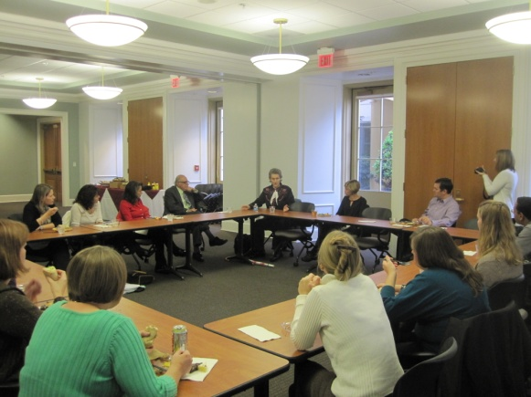

Session with faculty With the chair of our Board of Trustees

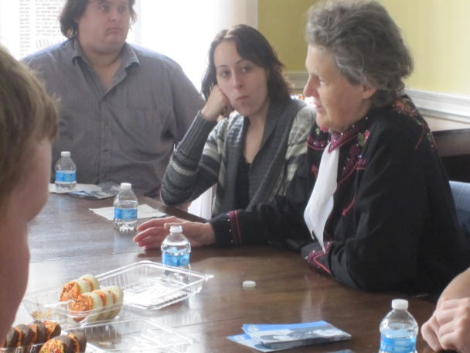
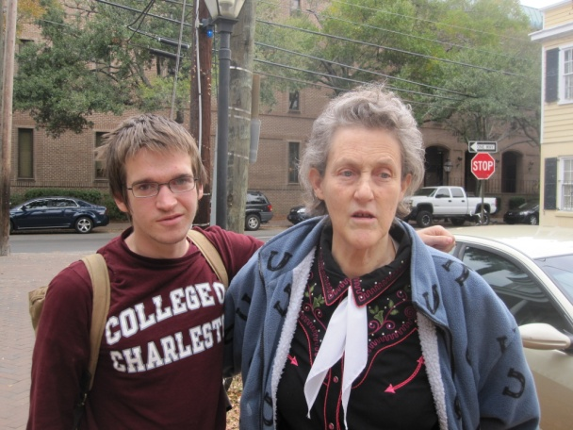

Mingling around campus
For news coverage of the event, go to: http://www.youtube.com/watch?v=ZcTjvzLgHjI

Initiative 2: Faculty and Staff Training in Universal Design
All faculty members who include REACH students in their courses are offered training by REACH staff. This year, though, we took it one step further. Because our advising center has worked closely with REACH students since the inception of our program, we were delighted when they came to us for training and guidance in supporting diverse learners. In response to their request, we invited Molly Boyle to campus to provide a half-day workshop for all staff in our advising center. In additional, Molly held two shorter sessions for faculty members, one focused on universal design in advising, and the other focused on universal design in syllabus development and assessment.
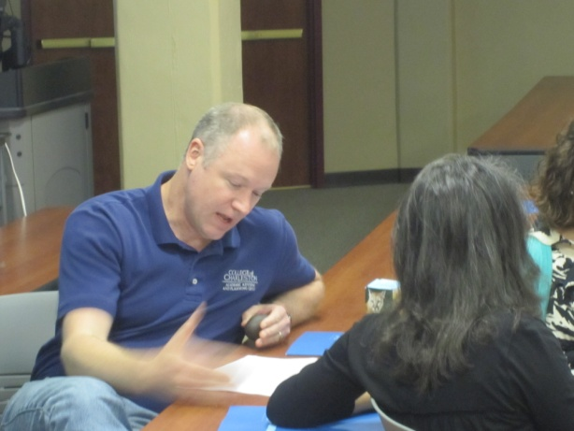
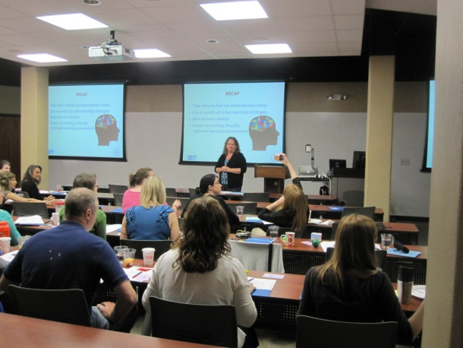
Participants in the workshop had very favorable responses to the sessions, with 97% of faculty members interested in a follow-up session in the fall. These workshops were promoted as sessions to improve pedagogy for all students (rather than specifically for teaching students with intellectual disabilities), with the aim of demonstrating that the techniques that are effective in supporting students with disabilities are also the techniques that are valuable for all learners in the classroom. Some highlights of the various training sessions are included below:

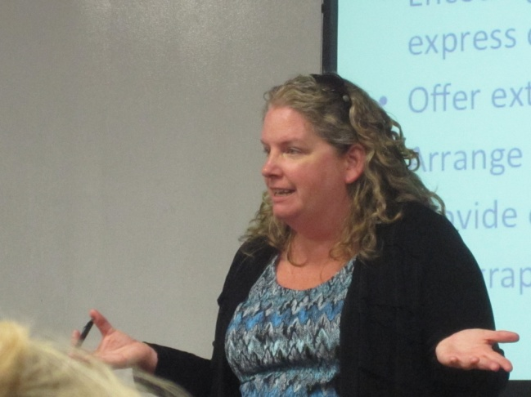
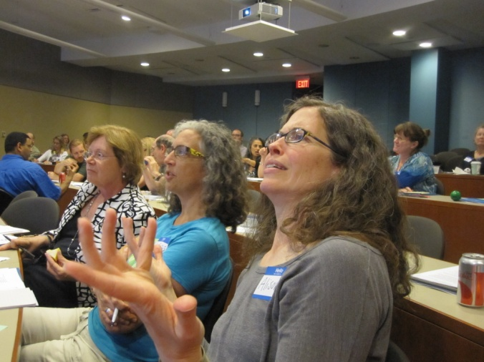

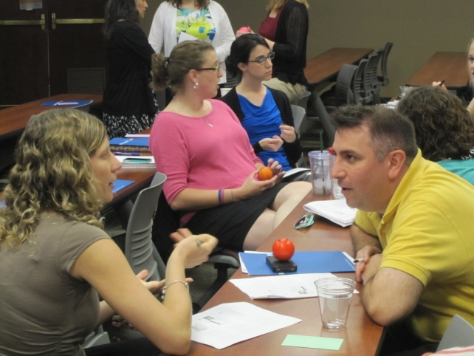
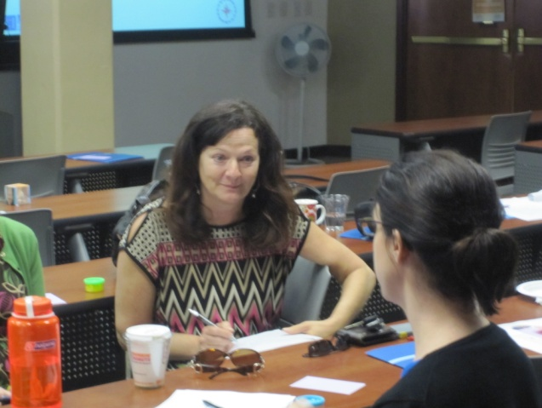

Initiative 3: Training current and future employers to create meaningful career opportunities for people with intellectual disabilities
Our most recent initiative (we haven’t even implemented this one yet!) is to create a mechanism that allows current and future employers to learn about meaningful inclusion of individuals with intellectual disabilities in the workplace. We are designing an initiative that will offer small grants to rising entrepreneurs who will create authentic employment opportunities for people with disabilities as an integral part of their business model. In order to compete for the small grant, applicants must first complete a training session on employment, disability, and universal design. The grant proposals will be reviewed by a panel that includes successful business owners and entrepreneurs, as well as experts in inclusion and employment of individuals with disabilities. The panel is designed to forge relationships between employers and our career staff, as well as to create a natural opportunity for employers to think critically about meaningful employment of individuals with disabilities. The tentative design of this project is provided below.

D.E.M.O.S.
Disability and Entrepreneurship: Models Of Success
The purpose of this initiative is to spawn new entrepreneurial endeavors that are not only successful business models, but also create meaningful career opportunities for individuals with intellectual disabilities. Historically, individuals with intellectual disabilities have had extremely limited employment options, and the positions that have been available have at times been created out of pity, benevolence, or a sense of civic duty. Often these positions have required very little of the employee and have offered minimal benefit to the employer. As a consequence, employees have low motivation and investment in the job, and employers have little incentive to maintain the position. These factors have resulted in very low success rates for employees with disabilities, and their positions are typically the first to be eliminated in a struggling economy.
The initiative is designed to move employment of individuals with disabilities beyond benevolence, with an emphasis on educating entrepreneurs and employers about the genuine value that individuals with disabilities bring to the workplace. We want employers to understand how to capitalize on the strengths and assets offered by employees with disabilities, and in doing so learn to create authentic and meaningful employment opportunities.
We will offer $5000 grants to support the development of new entrepreneurial endeavors that fully incorporate principles of universal design in their models. Successful proposals will be those that (a) offer a viable, competitive business model, (b) create meaningful, authentic employment opportunities for people with intellectual disabilities, (c) outline mechanisms for recruiting and supporting individuals with disabilities, and (d) offer goods or services that are universally accessible.
All applicants must first submit a one-page letter of intent indicating their intention to submit a grant proposal. Applicants will then participate in training sessions to learn about universal design, adaptation and accommodation, and recruiting and retention of employees with disabilities. Our goal is provide all the necessary support and education so that applicants create innovative, competitive business models that offer meaningful and authentic employment experience for individuals with disabilities.

